BIT/2024/57501
BIT4107:MOBILE APP DEVELOPMENT
WEEK1
Development tools
.Android studio
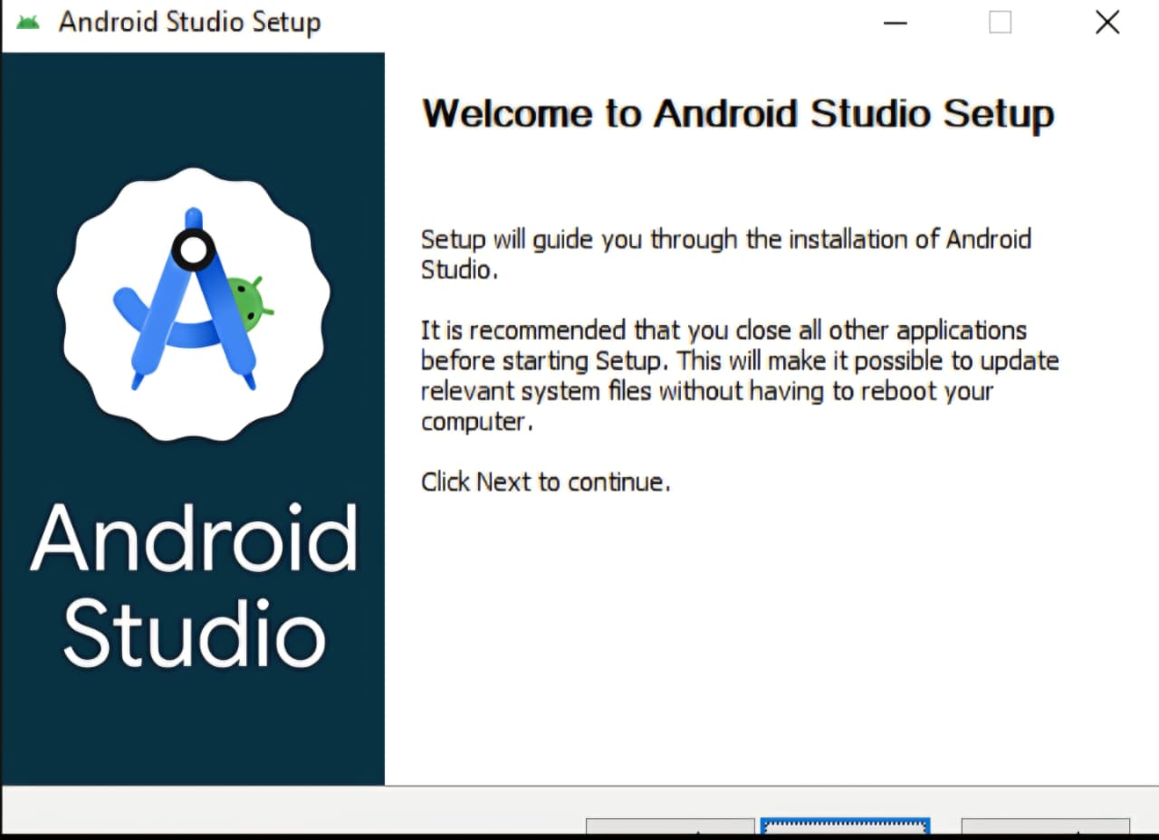
Used for writing code and managing files and debugging.
.Flutter extension.
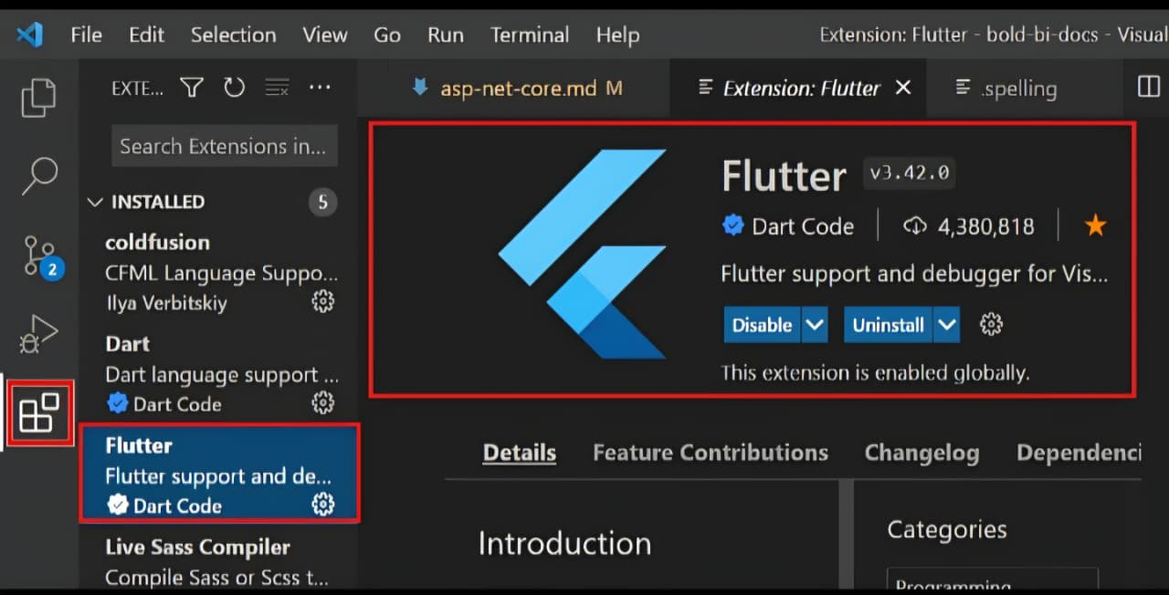
Used to enable flutter support on the IDE.
.Dart
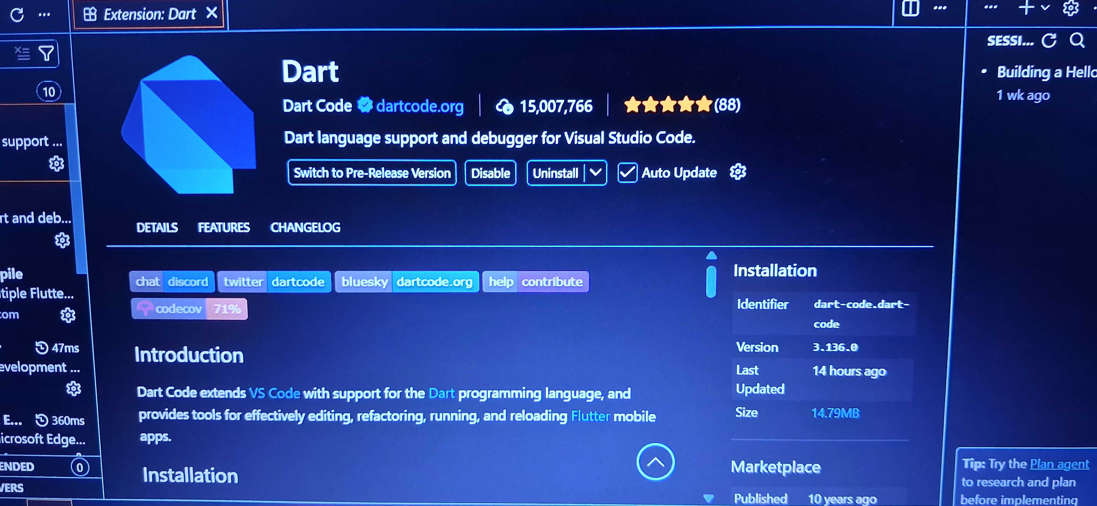
Programming language used to write flutter applications.
.Android emulator
Virtual devices used for testing the app UI

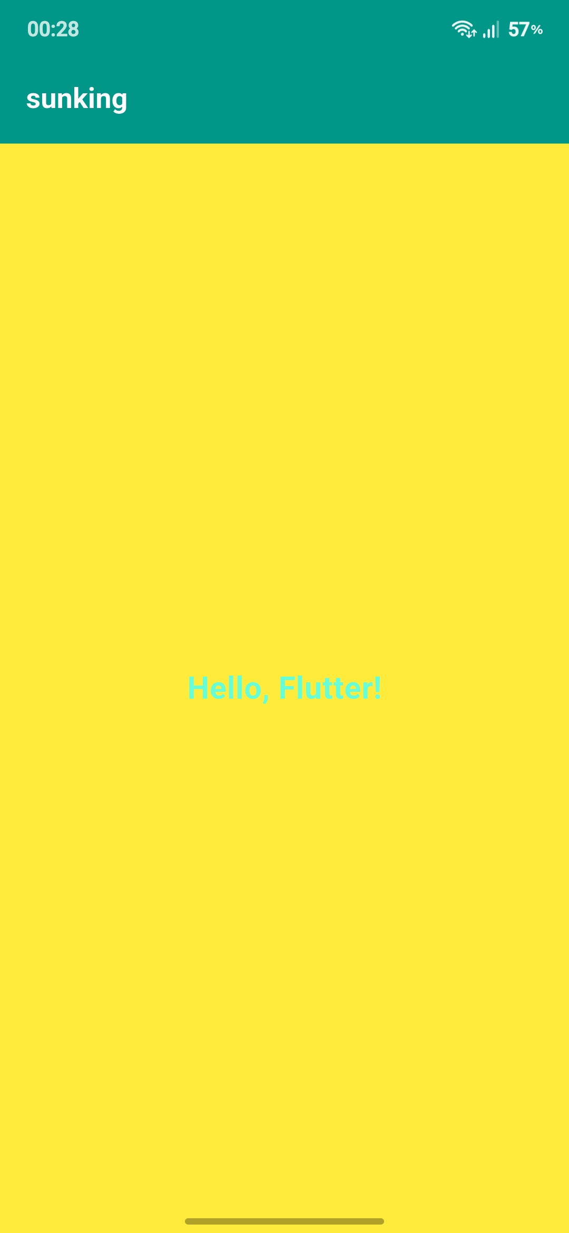
Screenshot of app name changed,,background color and font size.

import 'package:flutter/material.dart';
void main() {
runApp(const MyApp());
}

class MyApp extends StatelessWidget {
const MyApp({super.key});
@override
Widget build(BuildContext context) {
return MaterialApp(
title: 'Custom Flutter App',
debugShowCheckedModeBanner: false,
theme: ThemeData(
useMaterial3: true,
),
home: const HomeScreen(),
);
}
}
class HomeScreen extends StatelessWidget {
const HomeScreen({super.key});
@override
Widget build(BuildContext context) {
return Scaffold(
backgroundColor: Colors.blueGrey[900], // Background Color
appBar: AppBar(
title: const Text('My Custom Title'), // App Title
backgroundColor: Colors.teal,
foregroundColor: Colors.white,
),
body: const Center(
child: Text(
'Hello, Flutter!',
style: TextStyle(
fontSize: 36.0, // Font Size
fontWeight: FontWeight.bold,
color: Colors.tealAccent,
),
),
),
);
}
}
Source code of the created flutter app.
PERSONAL REFLECTION
Installing the tools was challenging at first due to errors and configuration issues, but it improved my problem-solving skills. I gained practical experience in setting up development environments and became more confident in using modern software tools for app development.

WEEK 2 ASSIGNMENT
Task management app
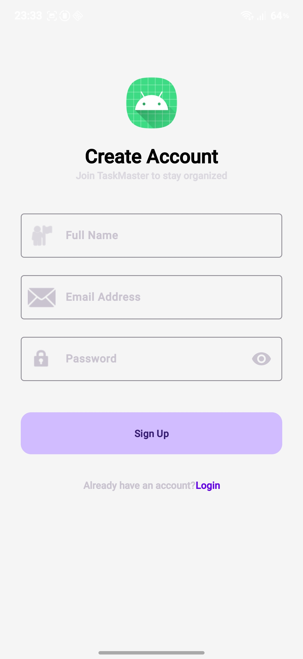
Screnshots of the login page that helps you navigate through the app by keying in the email address and passwords so as to log in or sign up.
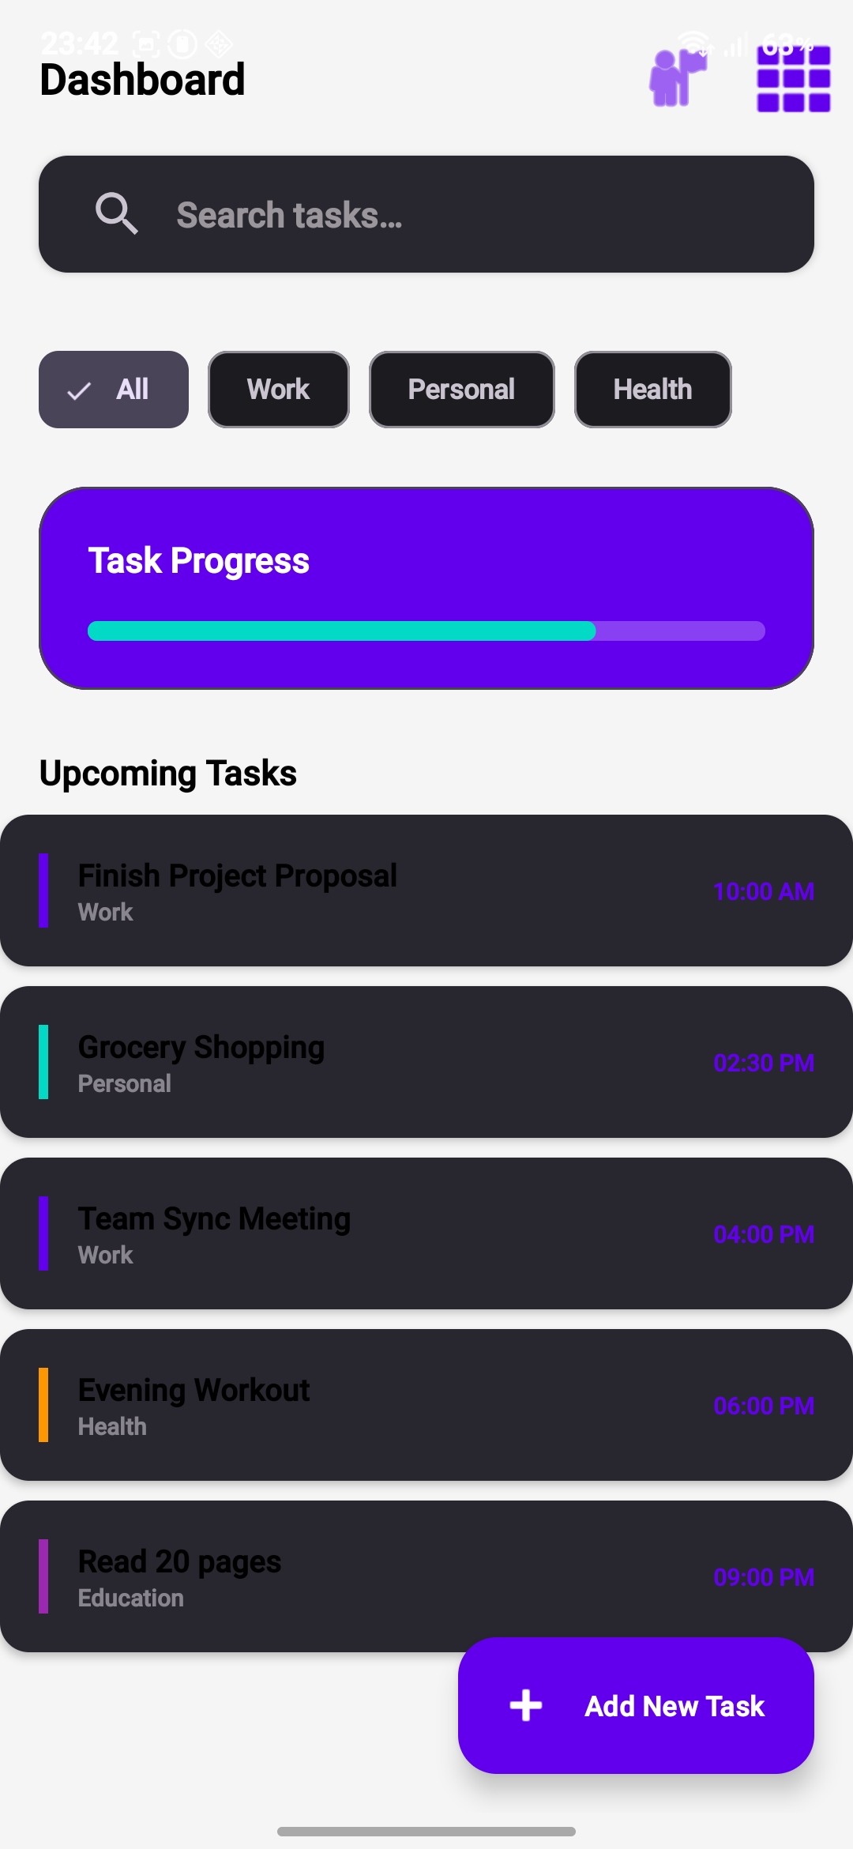
This is the dashboard that has features that helps you search and add new tasks and also helps you track and check you progress of the tasks.

WEEK3
UI PROTOTYPE
Tools used: Figma
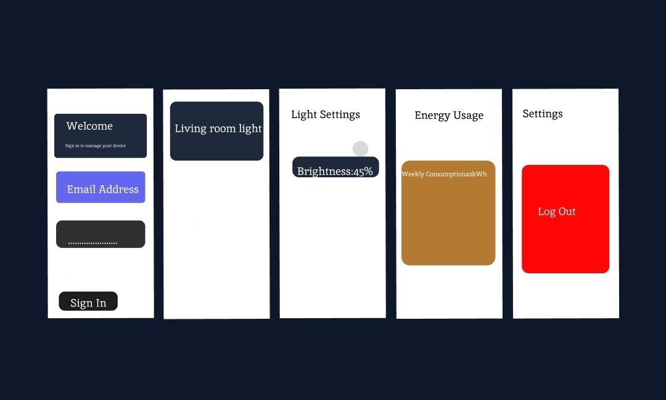
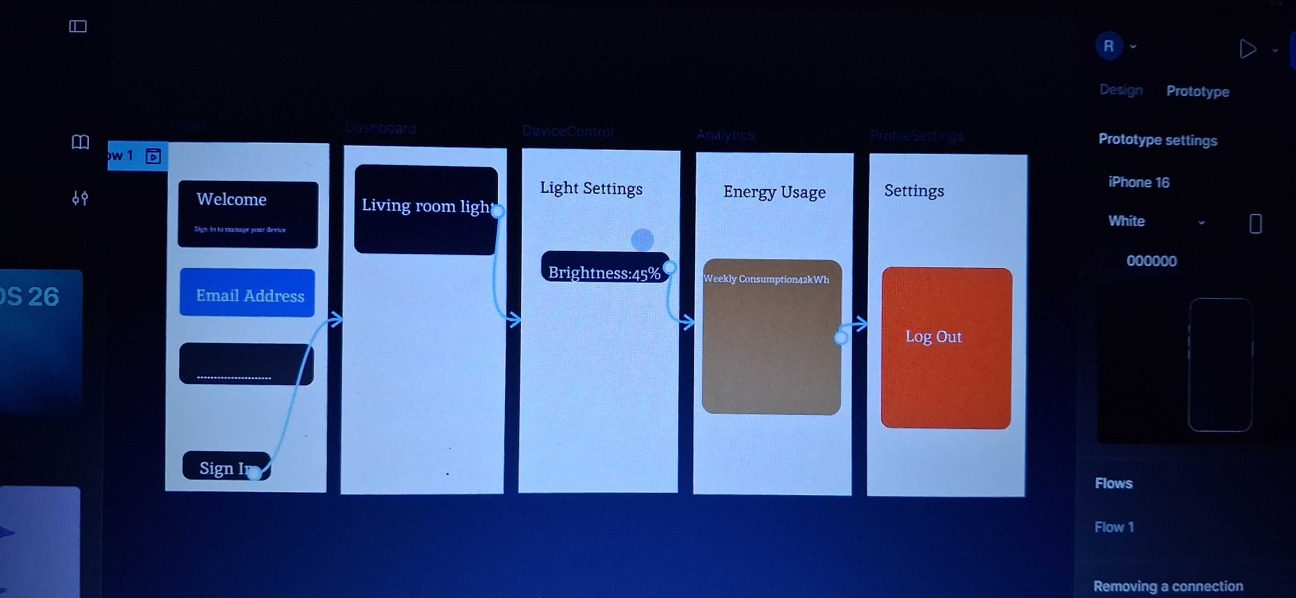
Screenshot showing clear navigations from login page screen so settings screen.

WEEK 4
DATA MANAGEMENT
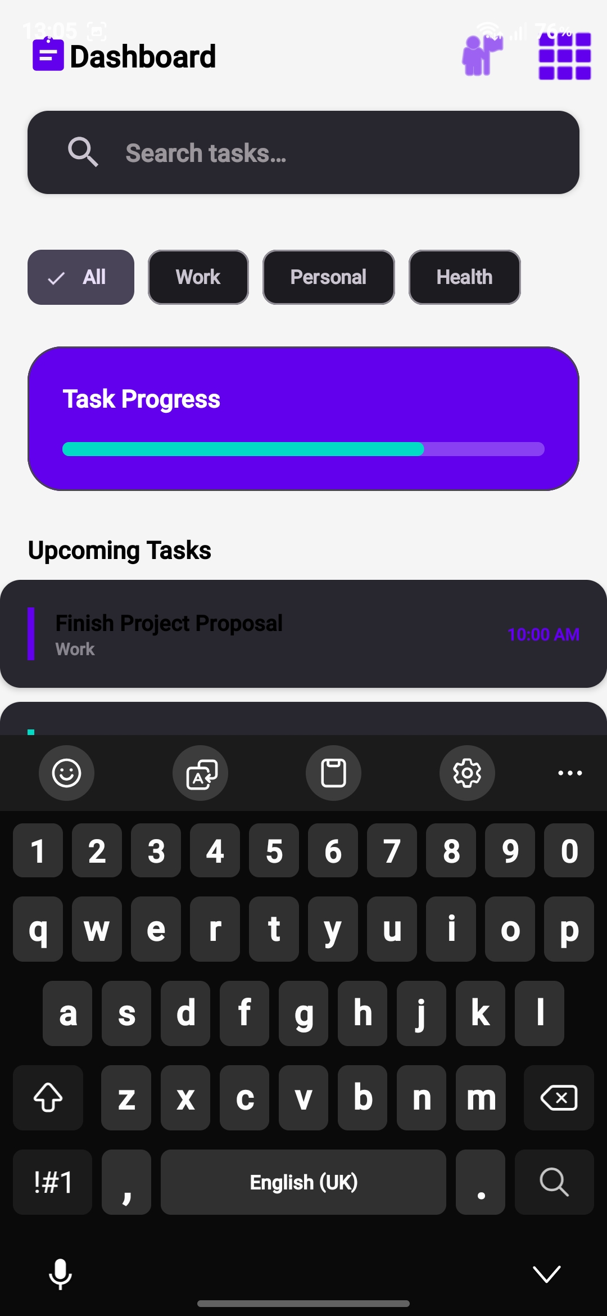
Screenshot of the add functionality
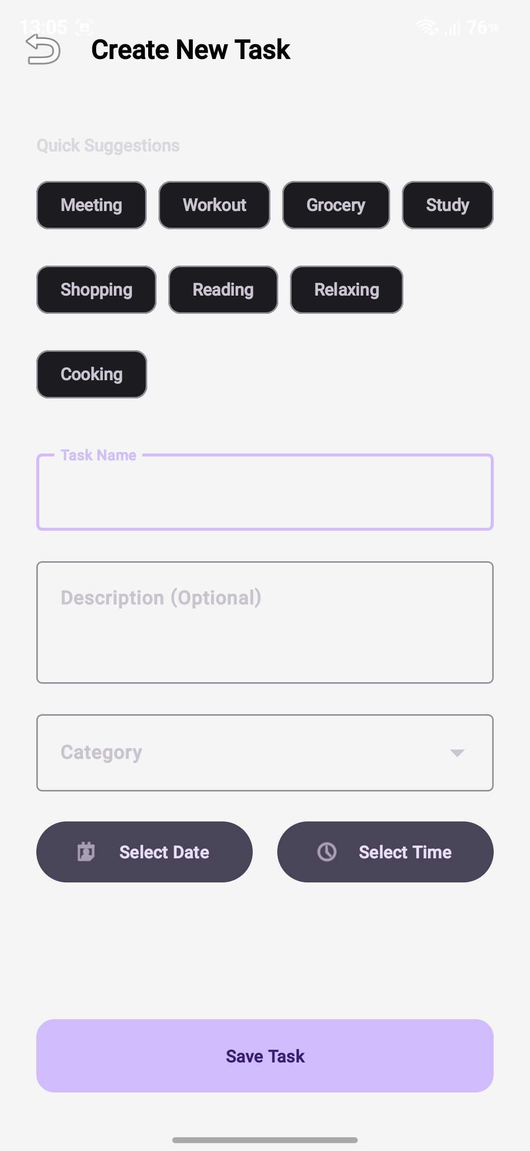
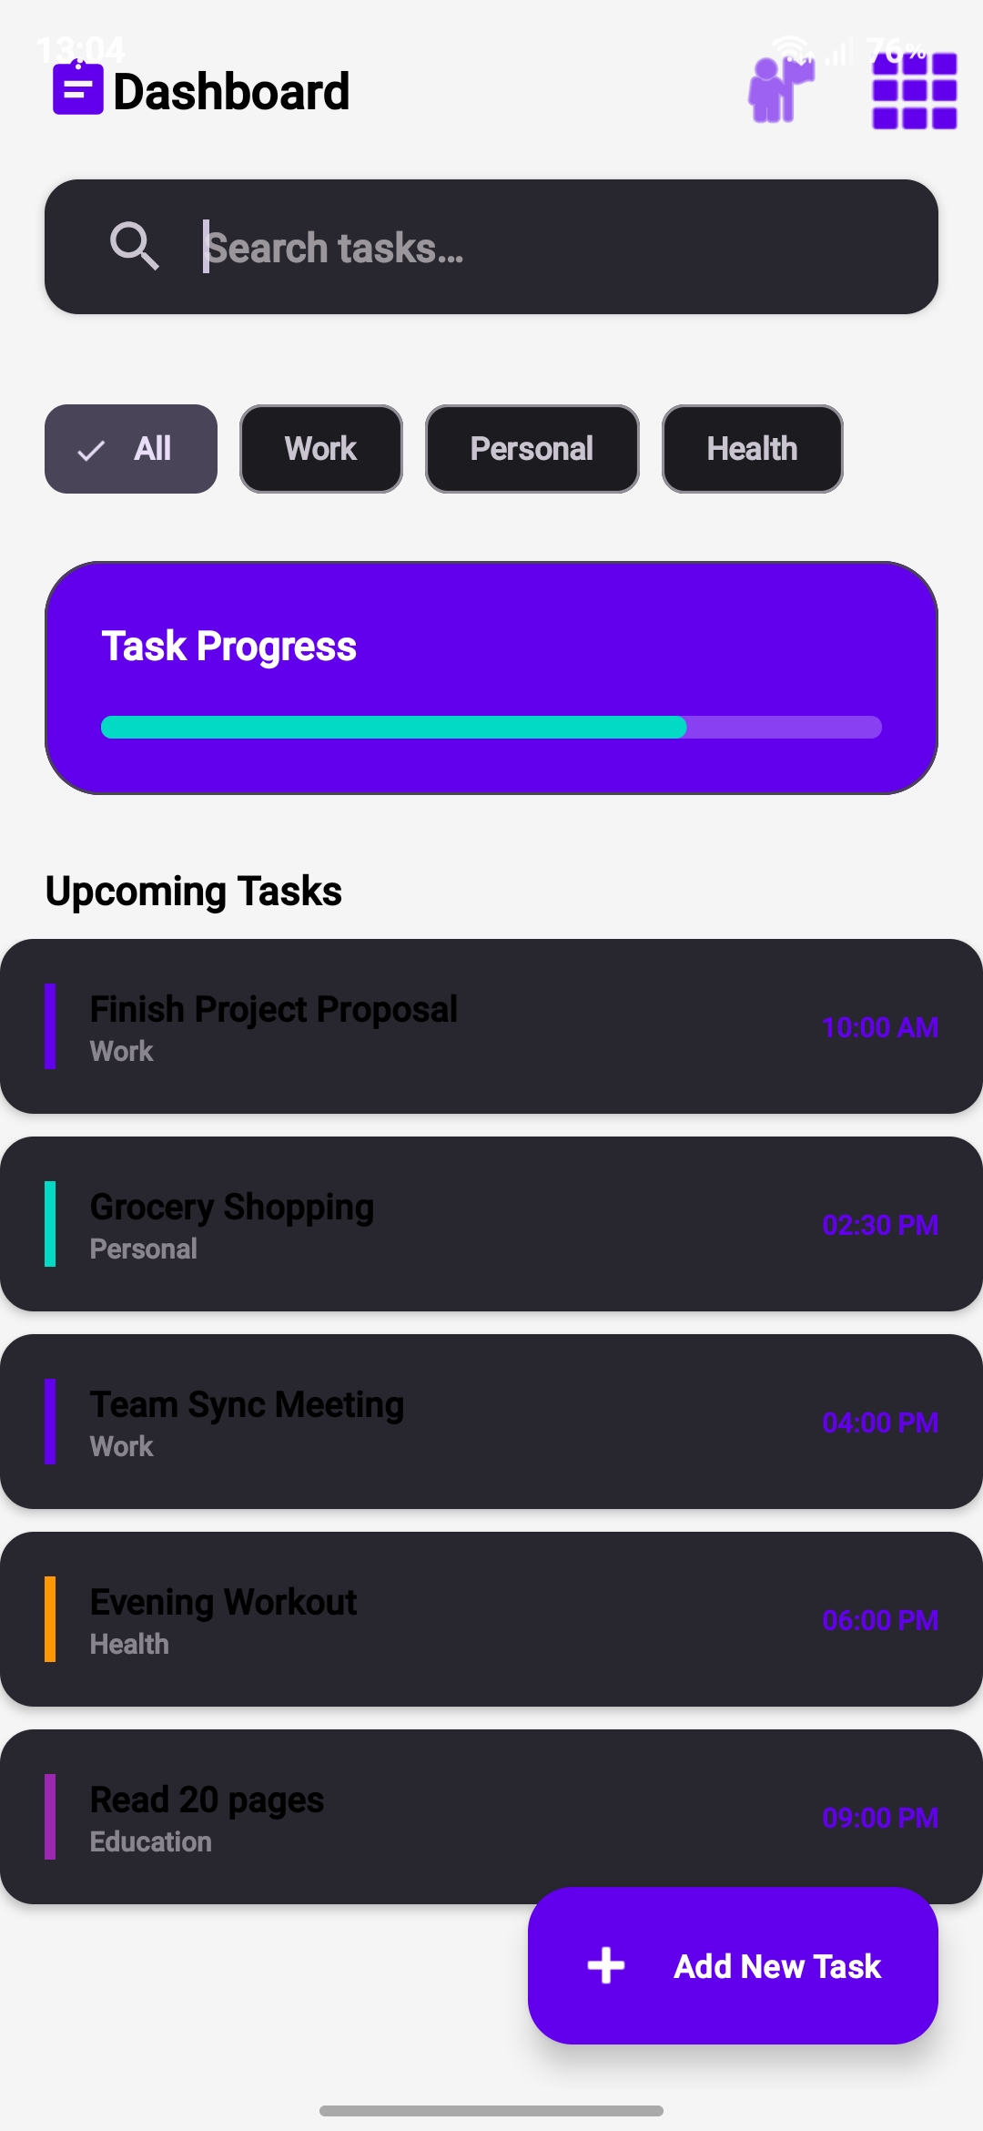
Add task functionality
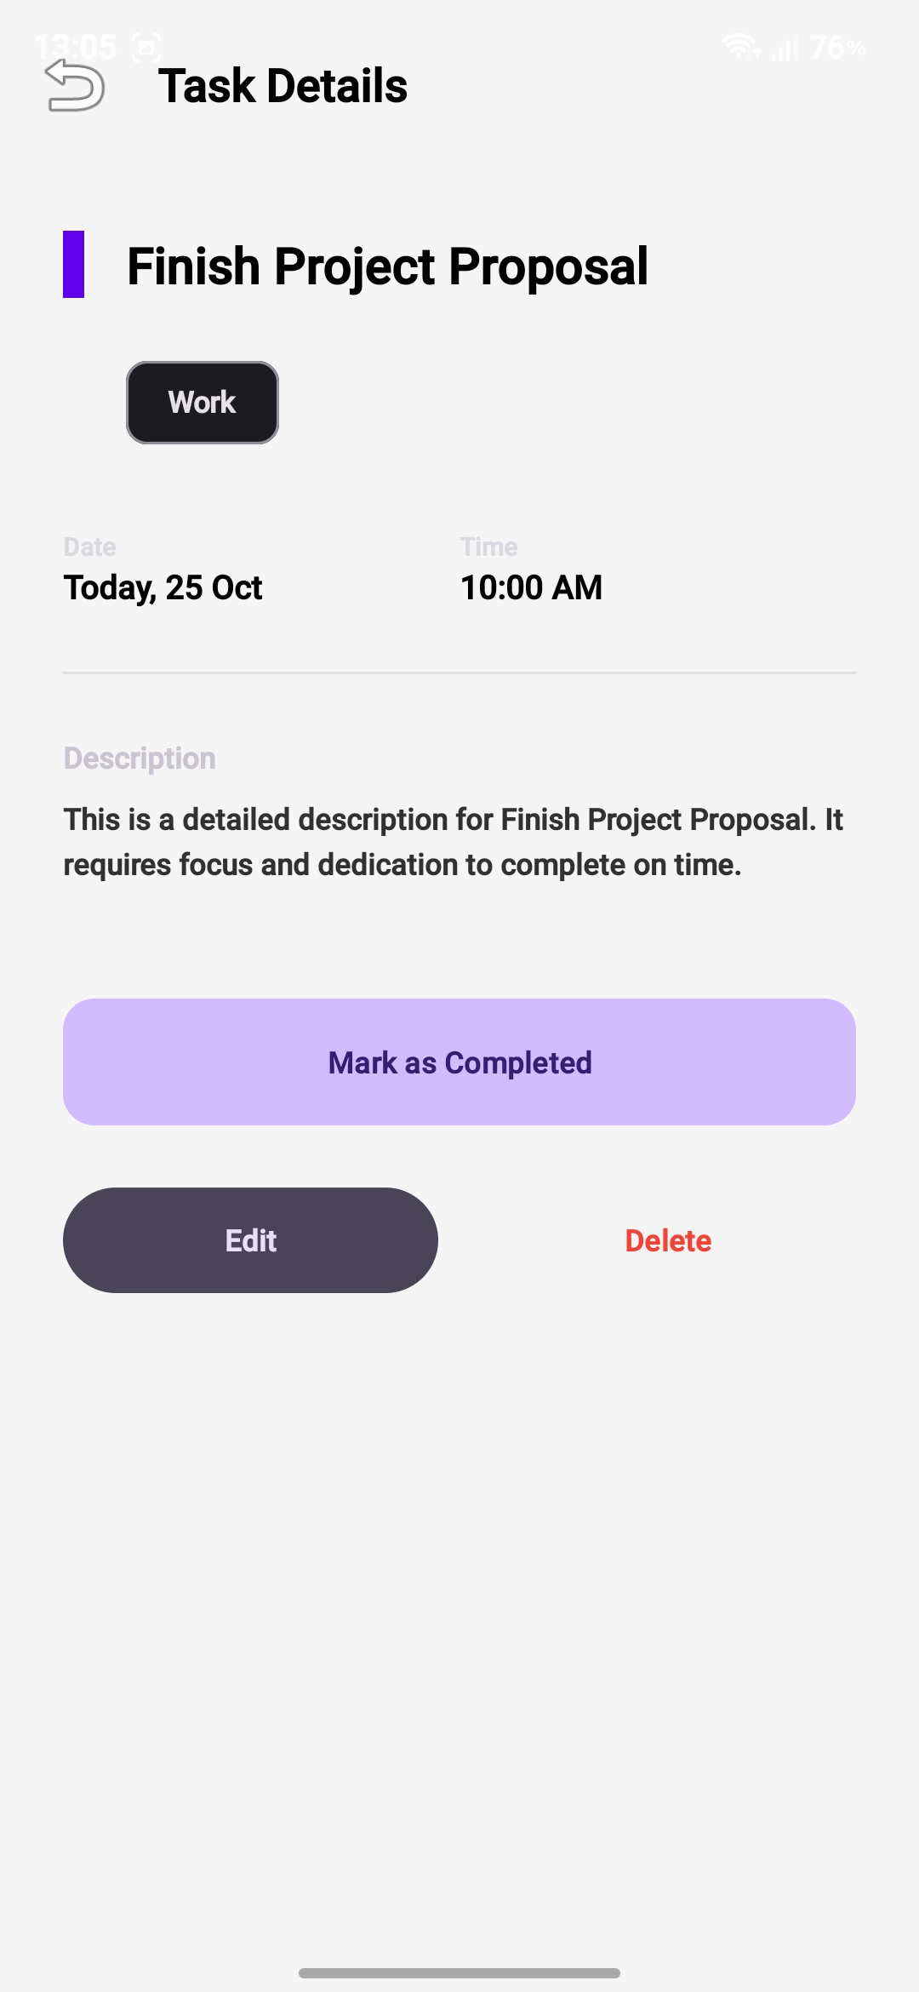
Delete function.
WEEK5/6
NETWORKING & APIs
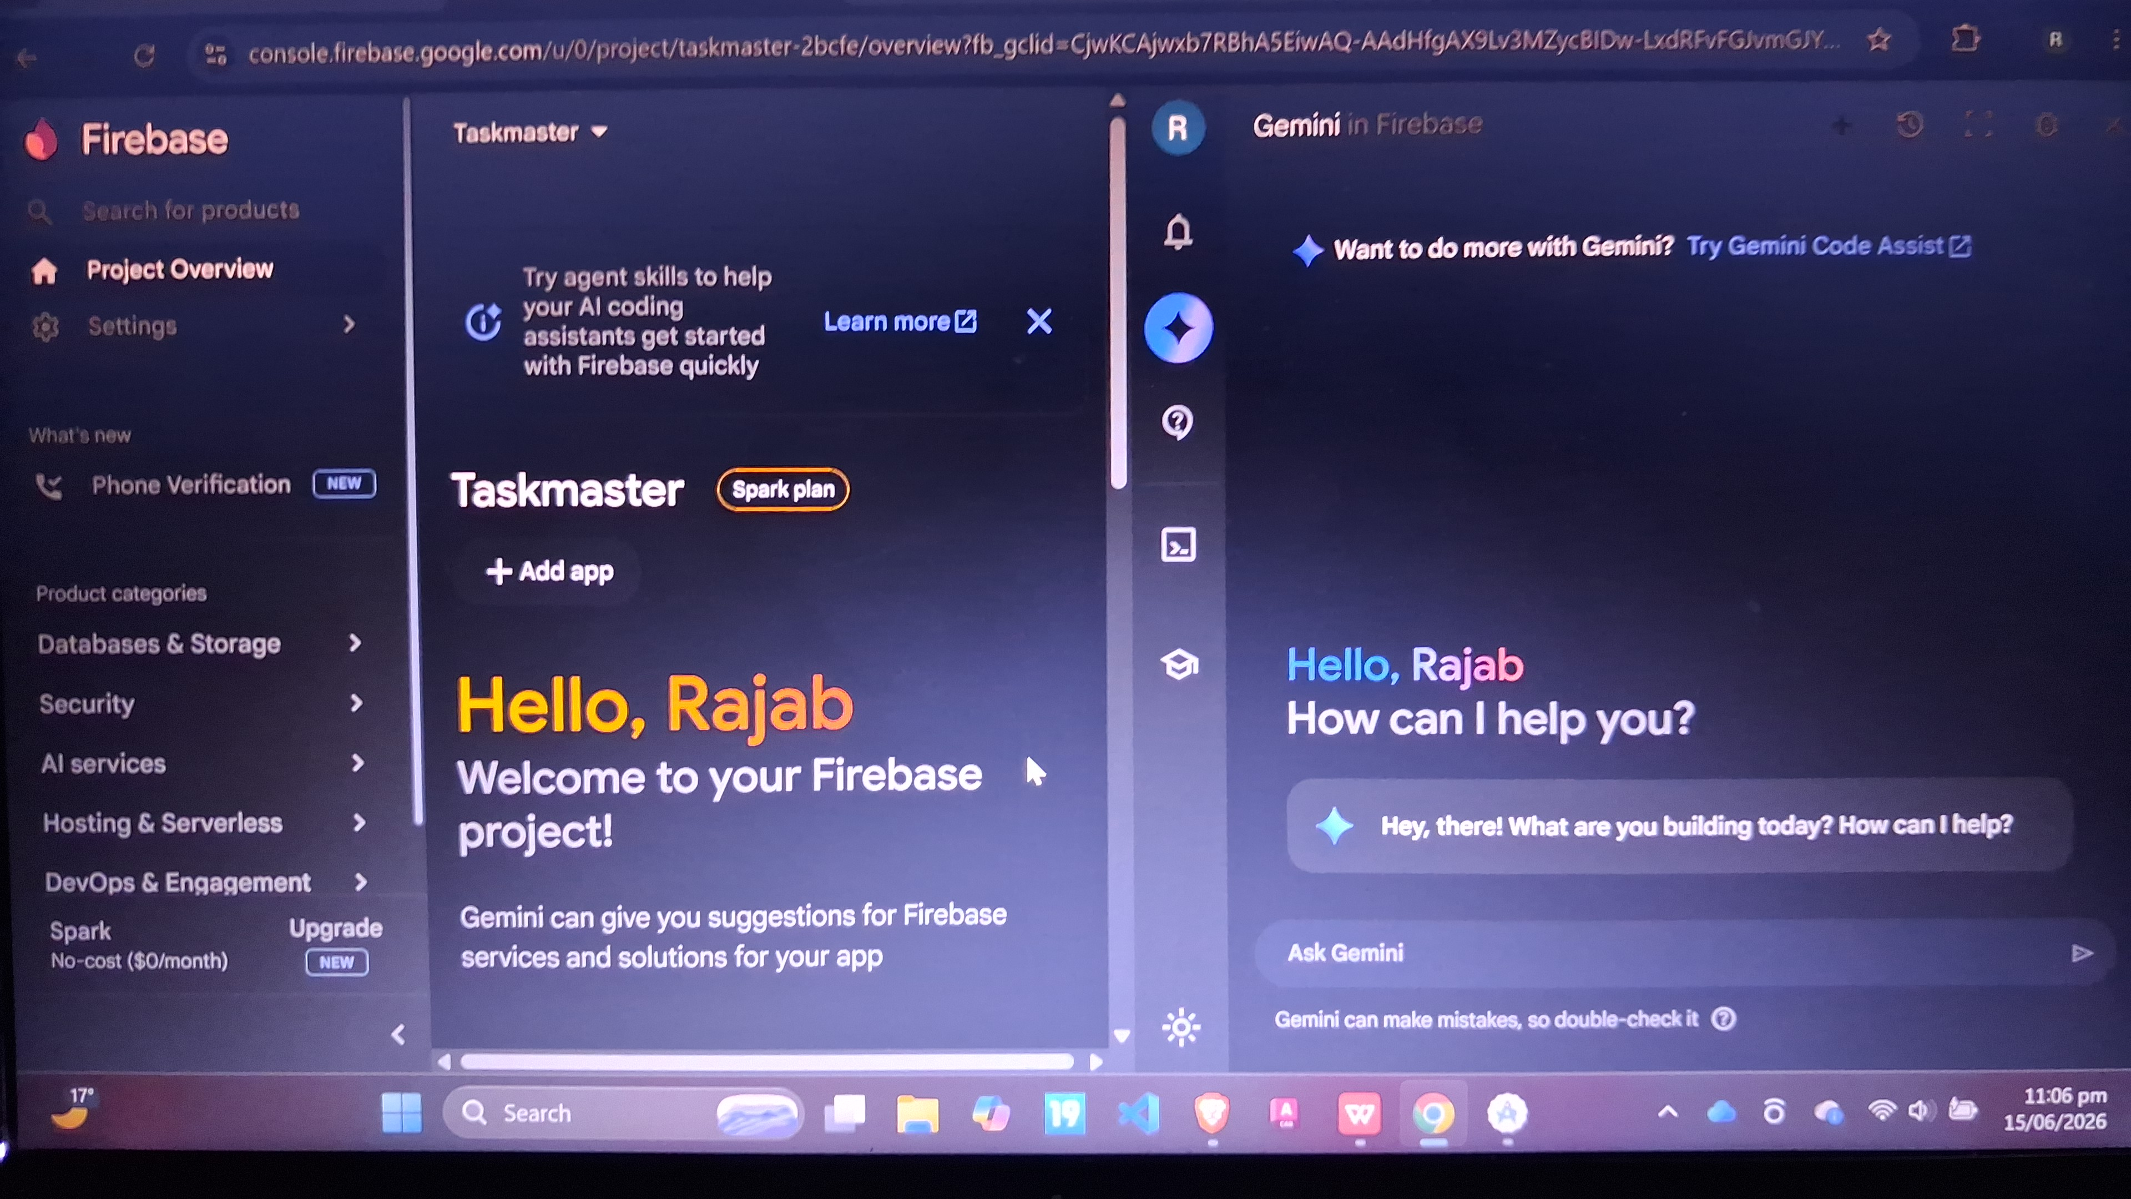
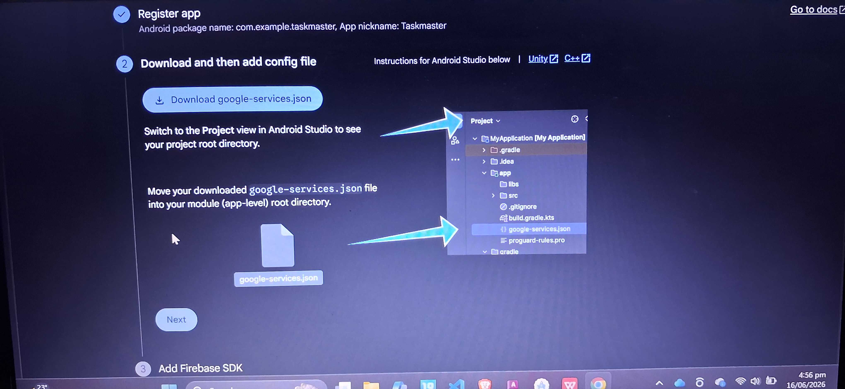
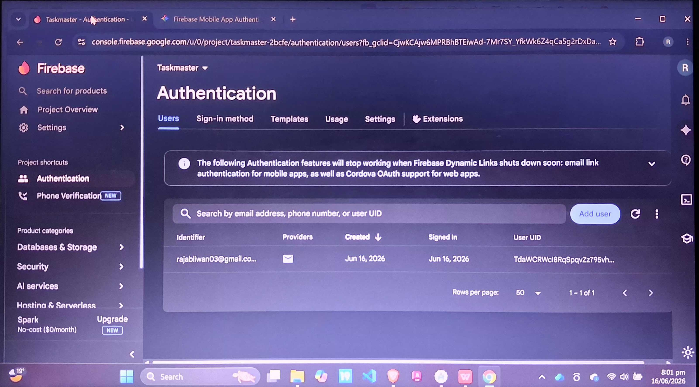

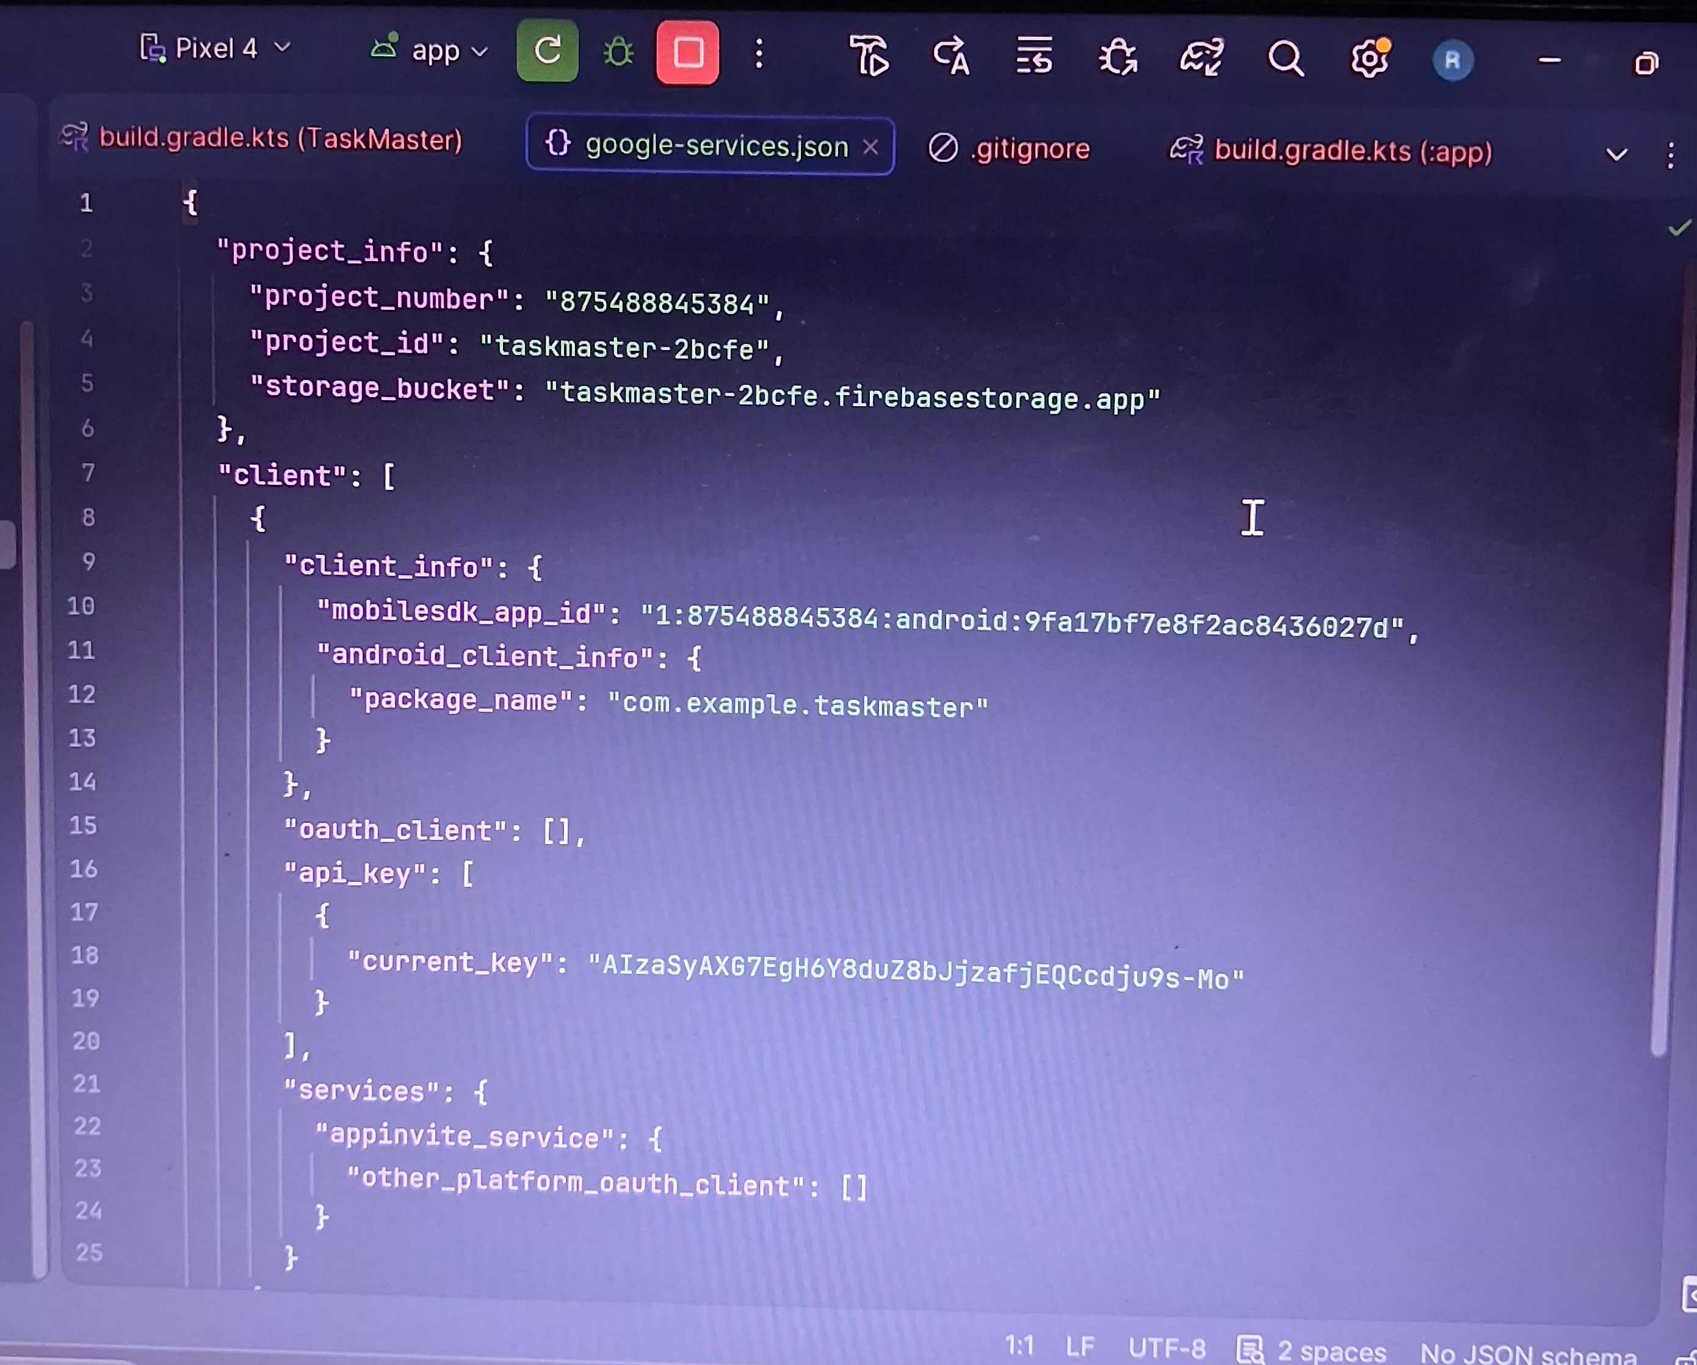
Screenshot of network connection string.
Personal reflection.
​Implementing Firebase Auth with Jetpack Compose successfully validated my local UI login logic and state transitions on the emulator. However, debugging a silent cloud-sync mismatch taught me how to navigate frozen Logcat daemons, manage emulator caches, and understand how modern BaaS architectures replace traditional connection strings with JSON configurations.

WEEK 7:DATA STORAGE AND DATABASE INTEGRATION IN MOBILE APPLICATIONS
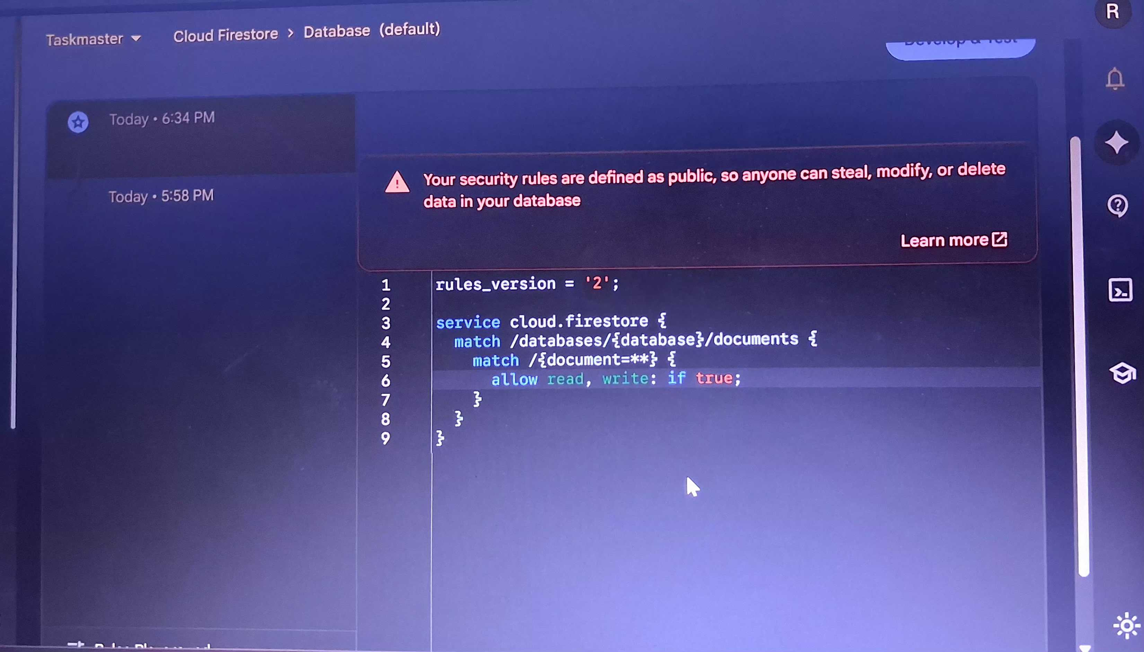

Cloud Firestore security rules configured to permit incoming data writes during the development and testing phase.
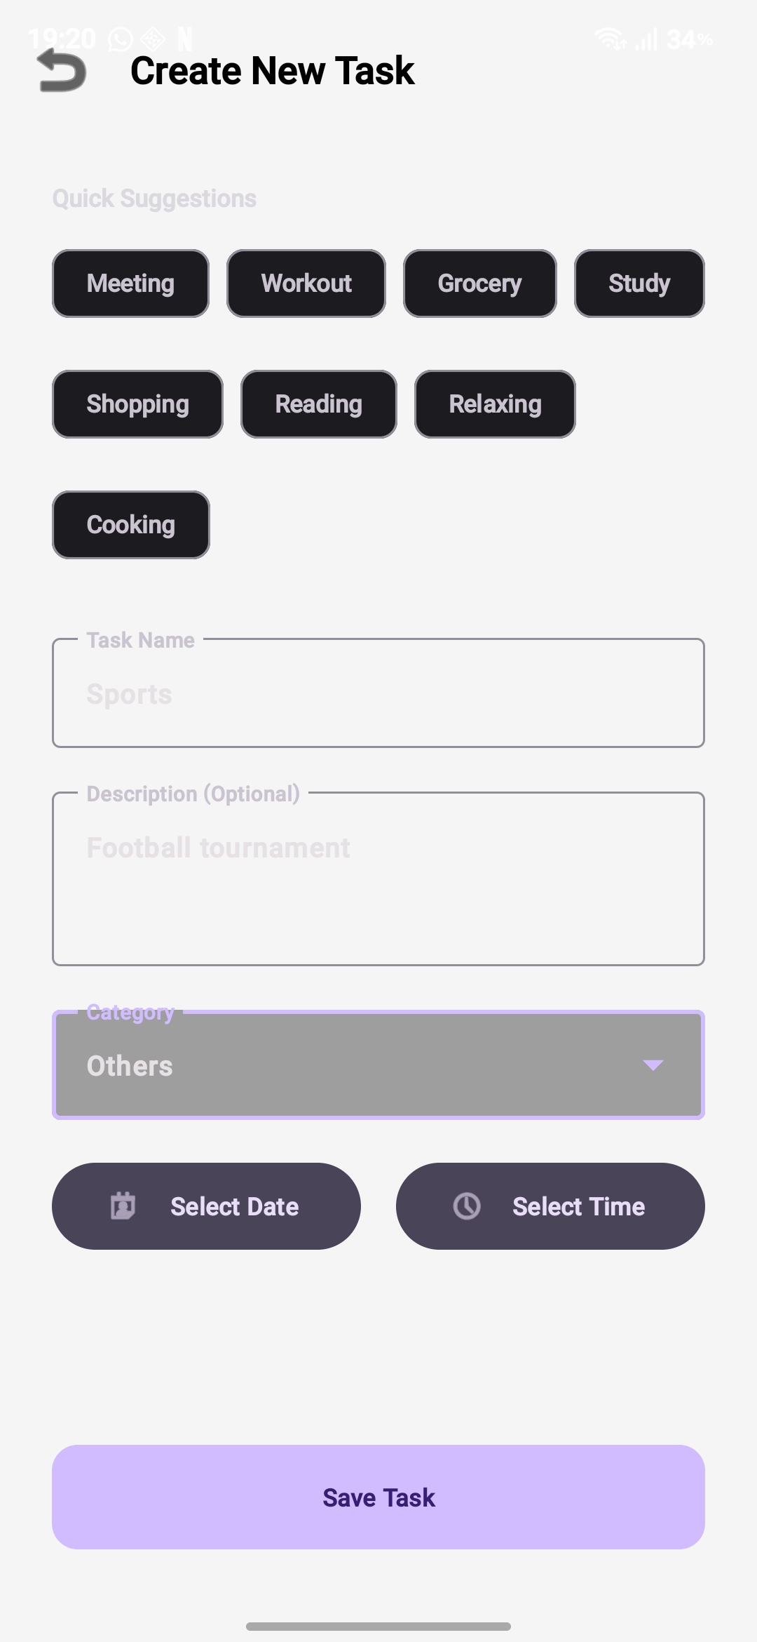
Taskmaster user interface displaying a populated task creation form prior to database submission.

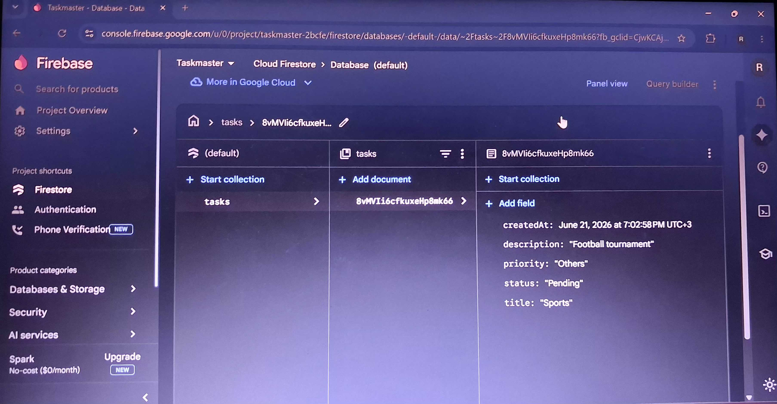
Real-time Cloud Firestore Data tab demonstrating successful data persistence and collection generation.
Personal reflection:Integrating Cloud Firestore with the Taskmaster app provided invaluable, hands-on experience in bridging a native Android frontend with a live cloud database.Overcoming configuration hurdles like network permissions and security rules highlighted the critical role of systematic troubleshooting in software engineering.Seeing local input successfully populate the cloud console in real-time significantly boosted my confidence in developing functional, full-stack applications.

